Reese King
Natural Hair Stylist
Specialist in natural hair care and protective styling
Licensed Cosmetologist with 7 years of experience focused on natural hair care, texture education, and protective styling. Deeply knowledgeable about coily, curly, and transitioning hair. Committed to healthy hair practices and empowering clients through education.

PROFESSIONAL EXPERIENCE

P E R S O N A L
I N F O R M AT I O N

(123) 456-7890

email@example.com Portfolio
City, ST

K E Y S K I L L S
Twist-outs and braid-outs Protective styling
Scalp care
Moisture retention strategies Client education
February 2020 - Present
Natural Hair Stylist | The Texture Lounge | Detroit, MI
Style 6–10 natural hair clients daily, including wash-and-gos, twist styles, and loc maintenance
Educate clients on curl patterns, porosity, and long-term care to support natural growth journeys
Introduced a deep conditioning treatment protocol that reduced client breakage complaints by 35%
Manage appointment bookings and Instagram marketing to increase monthly client leads
June 2016 - January 2020
Stylist | Crown & Coil Salon | Dearborn, MI

Offered protective styles, including box braids, flat twists, and crochet installations
Partnered with salon owner to host monthly “Curl Talks” events to promote education and community
Maintained detailed notes on client hair history, allergies, and sensitivities
Frequently booked 2–3 weeks out due to high demand and word-of-mouth referrals





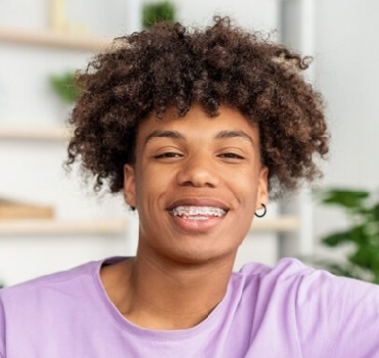
EDUCATION
Diploma in Cosmetology
Michigan College of Beauty | Troy, MI | 2016 |

