SHAWN WHITE
Makeup Artist
City, ST | (123) 456-7890 | email@example.comPortfolio


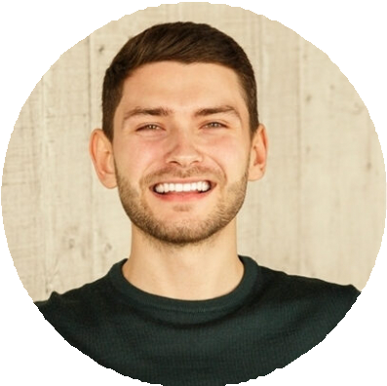

Bridal and Editorial Makeup Artist with eight years of experience creating high-impact looks for weddings, fashion shoots, and private clients. Skilled in airbrush application, contouring, color matching, and trend-based techniques.
Adept at working with diverse skin tones and managing high-pressure environments.

Airbrush application Bridal makeup Color correction Event coordination
Photography collaboration

Professional Experience
Lead Makeup Artist
Luxe Beauty Co. | San Diego, CA | April 2019 - Present
Design and execute makeup looks for weddings, photo shoots, and corporate events, serving up to six clients per day
Profile
Manage a team of four junior artists during large events, ensuring services are completed on time and to client's expectations
Consult with clients during trials to personalize looks and recommend skincare routines for optimal results
Collaborate with stylists and photographers to adjust makeup under studio lighting and HD camera settings
Freelance Makeup Artist
San Diego, CA | June 2015 - March 2019
Provided custom makeup services for private clients, including weddings, proms, and editorial photo shoots
Maintained a 5-star client rating on local directories and booking platforms through consistent service and client satisfaction
Key Skills
Managed bookings, client communication, and on-site setup independently while adhering to health and hygiene protocols
Stayed current with trends through ongoing training in contouring, product application, and multicultural beauty techniques

Education
Diploma in Cosmetology
Bellus Academy | Poway, CA | 2015,

