Reese King

R E C R U I T I N G S P E C I A L I S T

Recruiter focused on candidate experience and talent sourcing Strategic recruiting professional with 7 years of experience sourcing,
screening, and interviewing candidates across tech and administrative roles. Passionate about building inclusive pipelines, improving time-to-hire, and collaborating with hiring managers to align recruitment with business needs.

PERSONAL INFORMATION
PROFESSIONAL EXPERIENCE

Recruiting Specialist | Crimson Tech, San Diego, CA | October 2020 – Present

(123) 456-7890
email@email.com resume-site.com

Reduced average time-to-hire by 28% through pipeline optimization and hiring manager training
Sourced candidates using LinkedIn Recruiter and job boards for 50+ open roles Created inclusive job descriptions, resulting in a 35% increase in diverse applicants

City, ST

KEY SKILLS
Full-cycle recruiting
Boolean search and sourcing Job description writing Candidate screening Diversity hiring
Recruiting Coordinator | PureWave Media, San Diego, CA | June 2017 – September 2020

Managed interview scheduling and candidate tracking Built sourcing lists and conducted phone screens
HR Assistant | Seaside Financial, San Diego, CA | March 2016 – May 2017

Maintained employee ﬁles and assisted with hiring events

EDUCATION

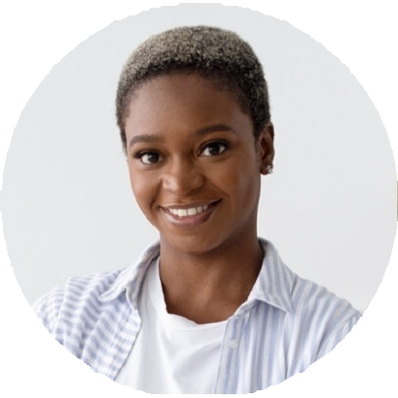




Bachelor of Science in Human Resource Development
San Diego State University | San Diego, CA | 2016 |

