Mark Rivera

Teaching Assistant

Teaching Assistant with three years of experience supporting undergraduate courses in biology. Proficient in lab supervision, grading, and developing supplemental instruction sessions to improve student outcomes.

Personal information

(305) 555-2233

markrivera@example.com LinkedIn | Portfolio
Miami, FL

Education
M.S. IN BIOLOGY | UNIVERSITY OF MIAMI | 2021
B.S. IN BIOLOGY | MIAMI DADE COLLEGE | 2019

Professional experience
TEACHING ASSISTANT | UNIVERSITY OF MIAMI, MIAMI, FL | SEPTEMBER 2021 - PRESENT

Led weekly lab sessions for 30 students, improving lab practical scores by 18%.
Graded assignments and provided feedback within 48 hours.

LAB ASSISTANT | MIAMI DADE COLLEGE, MIAMI, FL | JUNE 2019 - AUGUST 2021

Prepared lab materials and maintained equipment, reducing setup time by 25%.
Assisted with research projects, co-authoring one conference poster.

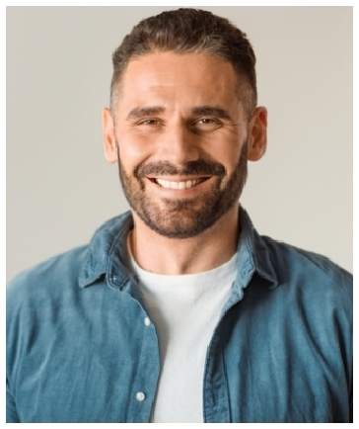





Key skills
Lab Instruction Grading & Feedback
Equipment Maintenance Supplemental Instruction

