Blake Allen

TeleDentist
TeleDentist delivering virtual care with precision and empathy Adaptable and tech-savvy TeleDentist with 7 years of experience providing remote
consultations, follow-ups, and diagnostic care. Proficient in EHR systems, video assessments, and patient education through digital platforms.

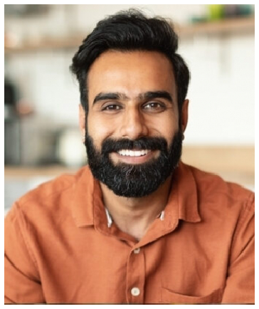




Contact information

(123) 456-7890

email@example.com City, ST 12345

Education
DOCTOR OF DENTAL MEDICINE (DMD) | ROSEMAN UNIVERSITY OF HEALTH SCIENCES | SOUTH JORDAN, UT | MAY 2016

Key skills
Asynchronous Care Reviews Digital Triage and Screening Ehr System Navigation
Patient Education via Telehealth Remote Diagnosis
Virtual Treatment Planning

Professional experience
TELEDENTIST | CARECONNECT DENTAL NETWORK, SALT LAKE CITY, UT | MAY 2019 - PRESENT

Managed 1,500+ virtual consults with a 92% patient satisfaction rate Reduced unnecessary ER referrals by 28% through timely triage
Conducted post-op follow-ups that improved treatment adherence by 18%

GENERAL DENTIST | RIVERBEND DENTAL, PROVO, UT | JULY 2016 - APRIL 2019

Integrated teleDentistry into existing workﬂows for post-treatment check-ins
Educated patients on oral hygiene and care between visits Used diagnostic imaging tools to prepare virtual treatment plans

