Jesse Martin

Endodontist
Precision-driven Endodontist focused on pain-free outcomes
Board-certified Endodontist with 9 years of experience in root canal therapy and endodontic surgery. Known for reducing patient pain and anxiety through efficient, compassionate treatment.

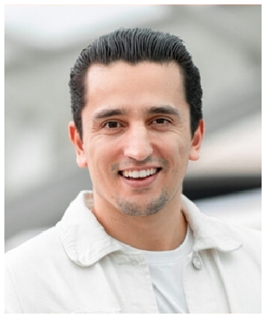





Personal information
(123) 456-7890
email@example.com LinkedIn
City, ST

Key skills
Apex Locator Use CBCT Evaluation
Endodontic Retreatments
Microscope-Assisted Procedures
Root Canal Therapy Surgical Endodontics

Education
DOCTOR OF DENTAL SURGERY (DDS) | UNIVERSITY OF ILLINOIS AT CHICAGO | CHICAGO, IL | MAY 2015

Professional experience
ENDODONTIST | PRECISION ENDODONTICS, CHICAGO, IL | OCTOBER 2017 - PRESENT
Completed over 2,500 root canals with a 96% long-term success rate Reduced average treatment time by 20% using rotary instrumentation systems Partnered with general Dentists for case referrals and co-treatment

ASSOCIATE DENTIST | LAKEVIEW DENTAL CENTER, CHICAGO, IL | AUGUST 2015 - SEPTEMBER 2017
Provided general Dentistry and assisted in endodontic cases Introduced patient pain tracking tools to monitor post-treatment recovery Managed referral relationships with local specialists

