Alex Lee

Junior Graphic Designer

Graphic design student with experience in animation and branding
Passionate graphic design student with experience working on high-profile animation projects at DreamWorks. Proficient in Adobe Creative Suite, typography, and design principles, with a record of executing design concepts and collaborating with clients to meet their needs.

Personal information

(555) 234-5678

email@example.com LinkedIn | Portfolio Glendale, CA

Education
CANDIDATE: BACHELOR OF FINE ARTS IN GRAPHIC DESIGN | RHODE ISLAND SCHOOL OF DESIGN, PROVIDENCE, RI | EXPECTED 2025

Professional experience
JUNIOR GRAPHIC DESIGNER | DREAMWORKS ANIMATION, GLENDALE, CA | MAY 2022 - PRESENT

Contribute to completion of five major animation projects by helping create graphic elements
Collaborated with senior designers and improved design efficiency by 15%

Certifications

Adobe Certified Expert (ACE) | Adobe
Certified Graphic Designer (CGD) | Graphic Designers of Canada

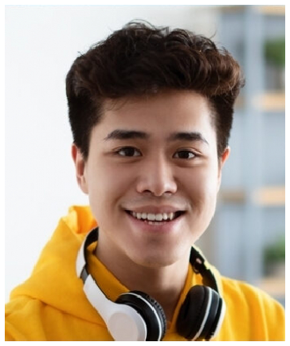





Key skills
Adobe Creative Suite (Photoshop, Illustrator, InDesign)
Animation design and 3D modeling Branding and identity design
Concept development and visual storytelling
Typography and color theory

