Sam Wright
Social Engagement Specialist
Social Engagement Specialist with five years of experience managing online interactions, boosting brand loyalty, and developing content that builds lasting relationships. Skilled in real-time engagement, sentiment analysis, and multi-platform moderation. Known for increasing retention through personalized community outreach.
PROFESSIONAL EXPERIENCE

P E R S O N A L
I N F O R M A T I O N

(000) 000-0000

sam.wright@email.com LinkedIn | Portfolio Minneapolis, MN 55401

K E Y S K I L L S

Community response Comment moderation Engagement metrics Sentiment reporting Social listening
June 2021 - Present
Social Engagement Specialist | Frostlight Games, Minneapolis, MN

Increased average response rate by 39% across Instagram and Discord through real-time engagement and automation workflows
Created monthly sentiment reports that led to changes in messaging tone and improved positive interactions by 22%
Tracked social KPIs and identified trends that helped reduce community churn by 16% year-over-year

May 2019 - May 2021
Community Moderator | Northbound Media, Minneapolis, MN

Managed conversations across Facebook and Reddit, handling up to 400 comments per week with a consistent brand voice
Responded to user inquiries and escalations, helping reduce negative sentiment and boost review ratings
Helped implement a feedback loop between audience insights and content planning sessions

EDUCATION

Bachelor of Arts (B.A.) in Digital Communication University of Minnesota, Minneapolis, MN | May 2019





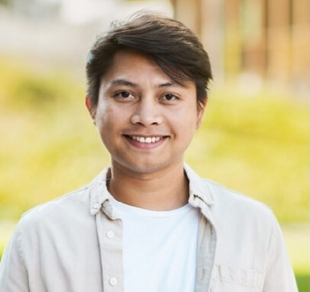
CERTIFICATIONS
Meta Certified Community Manager | 2022 Sprout Social Engagement Certification | 2021

