Sophia Reynolds

Pediatric Dental Hygienist

A B O U T M E
Dedicated pediatric dental hygienist with over five years of experience providing gentle and thorough oral care for children of all ages. Skilled in child-friendly communication, behavior management, and preventive care education. Passionate about making dental visits a positive experience for young patients.

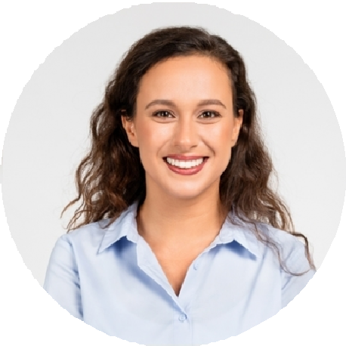



P E R S O N A L I N F O R M A T I O N

(123) 456-7890

sophia@example.com

Los Angeles, CA

E D U C A T I O N

Associate of Science in Dental Hygiene University of Southern California | Los Angeles, CA May 2017

K E Y S K I L L S

Pediatric oral hygiene education Behavior management techniques Sealant application
Digital X-rays and charting
Fluoride treatments

P R O F E S S I O N A L E X P E R I E N C E
Pediatric Dental Hygienist | June 2019 - Present
Happy Smiles Pediatric Dentistry | Los Angeles, CA
Provided gentle dental cleanings and preventive care to 30+ pediatric patients daily Educated children and parents on proper brushing and flossing techniques
Applied fluoride treatments and sealants to prevent cavities
Dental Hygienist | January 2017 - May 2019
Little Smiles Pediatric Dental | Pasadena, CA
Assisted in calming anxious children and ensuring a positive dental experience Took and reviewed X-rays to assess oral health and identify early signs of decay Maintained accurate patient records and sterilized instruments

C E R T I F I C A T I O N S
Registered Dental Hygienist (RDH) – June 2017
Certified in Pediatric Advanced Life Support (PALS) – July 2018

