LOGAN HALL
Personal Cook

ABOUT ME

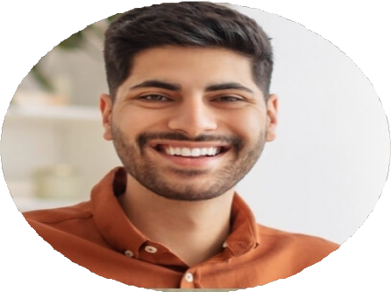

PERSONAL INFORMATION

 (123) 456-7890
 email@example.com
 Resume link | Portfolio link  City, ST

KEY SKILLS
Customized meal planning
Dietary restrictions
Grocery inventory
Kitchen organization
Nutritional cooking
Portioning
Recipe adaptation
Time management
Client-focused Personal Cook with a flair for customized meals
Personal Cook with 9 years of experience preparing meals in private households. Specializes in menu planning, meal prepping, and dietary accommodations, including gluten-free, vegan, and low-carb diets.

PROFESSIONAL EXPERIENCE
Personal Cook
Private Client – Hillside Estate, Dallas, TX | January 2019 - Present
Prepare daily meals for a family of six, incorporating speciﬁc nutrition plans
Handle grocery shopping and pantry rotation
Plan weekly menus based on family preferences and seasonal produce

Meal Prep Chef
FitFuel Prep Services, Dallas, TX | June 2015 - December 2018
Created custom weekly meals for up to 25 clients with individual dietary plans
Managed ingredient sourcing and weekly deliveries

EDUCATION
Diploma in Nutritional Cooking
Texas Culinary School | Graduated May 2015

