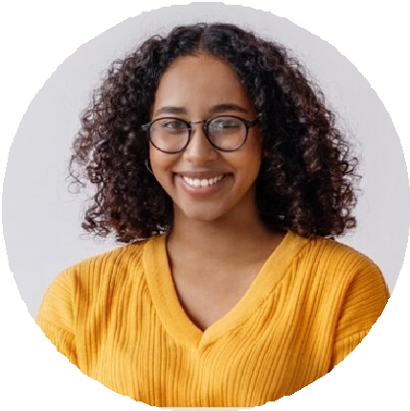




Avery Harris
Social Media Community Manager

Community-building expert for growing digital audiences Experienced community manager with 5 years of success fostering online
engagement across forums, Facebook groups, and Reddit. Build loyal audiences through authentic conversations, responsive moderation, and timely content delivery.

PROFESSIONAL EXPERIENCE
PERSONAL INFORMATION

Community Manager, VitalTech Software, Denver, CO July 2021 – Present
KEY SKILLS

(123) 456-7890

email@email.com LinkedIn | Portfolio City, ST 98765

Managed Facebook community of 30K+ members, increasing engagement by 60% in 12 months
Launched weekly user AMA sessions, leading to a 25% bump in active users Wrote community guidelines and led onboarding for volunteer moderators
Social Media Associate, LoopIt, Inc., Denver, CO May 2019 – June 2021

Scheduled and published content across social channels
Coordinated giveaways and polls that resulted in 2,000+ new followers Provided front-line customer support via Facebook Messenger
EDUCATION

Community engagement Group moderation
Reddit and Discord management
Facebook group growth User support
Event promotion

Bachelor of Science in Communication University of Colorado, Denver, CO | 2019

