Avery Harris

Corporate Cafeteria Cook
Organized Cafeteria Cook with a focus on consistency and customer service Cafeteria Cook with 8 years of experience preparing meals in office and campus dining environments. Known for punctuality, portion control, and clean, efficient kitchen practices.

PERSONAL INFORMATION

(123) 456-7890
PROFESSIONAL EXPERIENCE
COOK | NATIONAL BUSINESS COMPLEX CAFETERIA, INDIANAPOLIS, IN SEPTEMBER 2018 – PRESENT

email@example.com

Resume link | Portfolio lin k
- Prep and serve daily meals for 400+ employees in a rotating weekly menu
- Maintain strict safety logs and temperature tracking sheets
- Manage closing responsibilities and next-day prep

City, ST
CAFETERIA ASSISTANT | STATE TECH CAMPUS DINING, BLOOMINGTON, IN JUNE 2015 – AUGUST 2018

KEY SKILLS
- Assisted with breakfast and lunch service for 600+ students
- Trained in sanitation and commercial dishwashing procedures

  - Buffet setup
EDUCATION




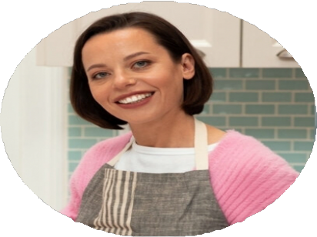
  - Cold food prep
  - Cross-contamination prevention
  - Daily station setup
  - Ingredient restocking
  - Portioning
  - Tray assembly
  - Waste reduction
  - Certificate in Foodservice Operations, Indiana Hospitality School | Graduated May 2015 |

