SAM WRIGHT
Skincare Specialist

ABOUT ME

PERSONAL INFORMATION

(123) 456-7890

email@example.com Portfolio
City, ST

KEY SKILLS
Advanced facials
Product recommendations Skin analysis
LED and high-frequency tools Client treatment tracking
Licensed Skincare Specialist with expertise in facials and advanced treatments
Dedicated Esthetician with 6 years of experience in providing customized facial treatments and skin consultations. Skilled in chemical peels, acne facials, microdermabrasion, and LED therapy. Committed to holistic skin health and personalized service.

PROFESSIONAL EXPERIENCE
Skincare Specialist
Clear Glow Spa | Denver, CO | January 2021 - Present
Perform 20+ facial treatments weekly, tailored to client's skin concerns and goals
Develop treatment plans for clients managing acne, aging, and hyperpigmentation
Recommend home care regimens, contributing to a 60% increase in retail product sales
Collaborate with massage therapists and receptionists to coordinate seamless service delivery





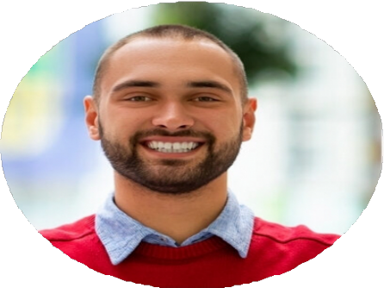
Esthetician
Nu Image Studio | Aurora, CO | May 2017 - December 2020
Specialized in anti-aging facials, dermaplaning, and microdermabrasion treatments
Tracked client progress and adapted services based on product response and seasonal needs
Consistently ranked among the top 3 for monthly client retention and referrals Educated clients on ingredient interactions and product layering techniques

EDUCATION
Esthetics Certiﬁcation
The School of Botanical and Medical Aesthetics | Denver, CO | 2017

