Reese King
Spa Receptionist

Calm and attentive Spa Receptionist with 3 years of experience delivering exceptional guest experiences in luxury wellness settings
Manages appointment flow, client service, and POS transactions with efficiency and grace. Adept at promoting spa services and managing a serene environment.

Personal information

(000) 000-0000

Professional Experience
SPA RECEPTIONIST | AURA WELLNESS SPA, TAMPA, FL JANUARY 2022 - PRESENT

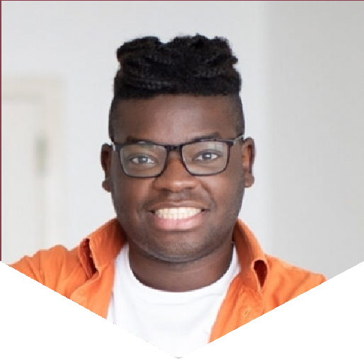

 reese.king@email.com City, ST

Key skills

Spa scheduling software (MindBody, Zenoti)
Upselling and service promotion
Front desk management Gift card and retail sales Daily cash handling Sanitation compliance
Schedule over 50 daily appointments and coordinate with 10 therapists Promote packages and handle billing through Zenoti
Maintain front lounge ambiance and cleanliness

RECEPTIONIST | TRANQUILITY SPA, TAMPA, FL OCTOBER 2020 - DECEMBER 2021
Managed check-ins and rescheduled bookings Trained in skincare product lines for upselling Assisted in inventory restocking and POS systems

Education
High School Diploma
Clearwater High School, Clearwater, FL | 2020

