Benjamin Clark
Fine Dining Bartender
Fine dining bartender with over nine years of experience crafting upscale cocktails and pairing wines in Michelin-starred restaurants. Specializes in sophisticated mixology, table-side cocktail preparation, and enhancing guest dining experiences with curated beverage selections.

PERSONAL INFORMATION
(321) 987-6540

benjamin.clark@example.co m

Chicago, IL

KEY SKILLS
Luxury cocktail service Wine and spirit pairing Table-side mixology
Guest relations in ﬁne dining Premium ingredient sourcing

PROFESSIONAL EXPERIENCE
June 2019 - Present

Senior Bartender, Le Château, Chicago, IL
- Created a refined cocktail program that increased wine and cocktail pairings by 35%
- Provided table-side cocktail service, offering personalized recommendations for an elite clientele
- Trained junior bartenders on proper glassware selection, spirit aging, and presentation techniques
August 2014 - June 2019

Bartender, The Grand Table, Chicago, IL
- Assisted sommeliers in curating wine pairings for tasting menus and fine dining guests
- Maintained a meticulous bar setup, ensuring top-tier service for high-profile patrons

EDUCATION

Bachelor of Science in Hospitality & Culinary Arts
University of Chicago, IL | June 2014

CERTIFICATIONS

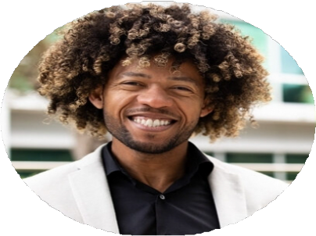



Certified Sommelier (CMS Level 1), September 2018
ServSafe Alcohol Certification, June 2014

