Liam Rodriguez
Film production student with experience in cinematography and editing
Film student with 10+ video projects edited and production support for 5 commercial shoots; boosted client engagement with polished final cuts.

PRODUCTION ASSISTANT
P R O F E S S I O N A L E X P E R I E N C E
XYZ STUDIOS, CITY, ST | MAY 2023 – PRESENT

City, ST
- Assist with lighting setup, sound recording, and scene coordination for film shoots
- Edit footage and collaborate with directors to produce final cuts

(555) 234-5678
FREELANCE VIDEO EDITOR
SELF-EMPLOYED, CITY, ST | JUNE 2022 – APRIL 2023

liamrodriguez@email.com

LinkedIn URL | Portfolio: liam films.com
- Edited short films and promotional videos for local businesses and artists
- Increased client engagement through high-quality, visually compelling content

K E Y S K I L L S
E D U C AT I O N
BA in Film Production (Expected May 2026) University of City, City, ST





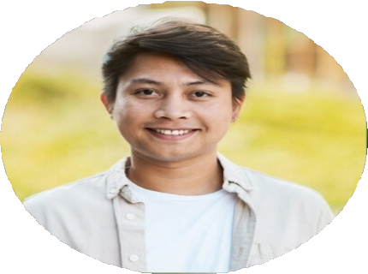
- Video production and editing
R E F E R E N C E S
- Cinematography and lighting
- Scriptwriting and storytelling
- Adobe Premiere Pro and Final Cut Pro
- Sound design and mixing

