Ava Richardson
Theme Park Bartender

Theme park bartender with six years of experience providing beverage service in large-scale entertainment venues. Specializes in themed cocktails, high-volume service, and maintaining an engaging guest experience in dynamic, family-friendly environments.

Location
Orlando, FL

Phone
(321) 987-4560

Email
ava.richardson@example.com

Website
LinkedIn

University of Central Florida, Orlando, FL | June 2017

Associate Degree in Hospitality & Event Management

Bartender, Adventure Cove Theme Park, Orlando, FL May 2020 - Present

- Serve custom, themed cocktails to thousands of guests daily in an immersive, high-energy environment
- Maintain a family-friendly approach while adhering to alcohol service regulations in a theme park setting
- Created a specialty cocktail lineup for seasonal park events, increasing beverage sales by 25%

Bartender, Fantasy Kingdom, Orlando, FL July 2017 - May 2020

- Provided high-speed service during peak park hours, serving over 400 guests per shift
- Trained seasonal bartenders on park-specific service standards and responsible alcohol service

- TIPS Alcohol Certification, May 2017


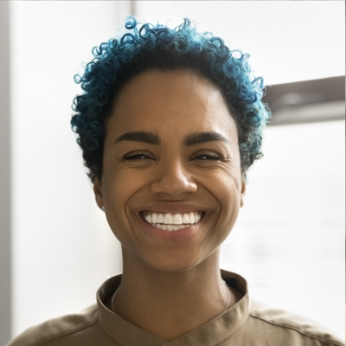

Themed cocktail creation High-volume bartending Guest engagement Family-friendly service
Event-based beverage sales

