Reese King

Cosmetic Dentist

Cosmetic Dentist focused on function and esthetics
Experienced Cosmetic Dentist with 10 years in veneers, whitening treatments, and smile makeovers. Adept in digital design software and modern materials for lifelike, durable results.

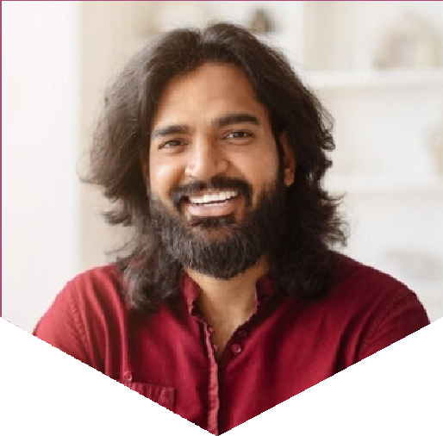

Contact information

(123) 456-7890

 email@example.com  City, ST 12345

Key skills

Composite Bonding Cosmetic Case Presentation Digital Smile Design Porcelain Veneers
Shade Matching Teeth Whitening

Professional Experience
COSMETIC DENTIST | TRUESMILE AESTHETICS, SCOTTSDALE, AZ FEBRUARY 2017 - PRESENT
Designed and placed over 600 veneer sets with a 98% satisfaction rating Increased high-end treatment conversions by 35% using digital mockups Launched a patient referral program that grew practice volume by 20%
GENERAL DENTIST WITH COSMETIC FOCUS | VALLEY DENTAL GROUP, PHOENIX, AZ
AUGUST 2014 - JANUARY 2017

Provided whitening, bonding, and minor ortho for adult patients Educated patients on esthetic options during routine cleanings Co-developed in-house whitening protocol with staff hygienists

Education
Doctor of Dental Medicine (DMD)
Midwestern University | Glendale, AZ | May 2014

