SOPHIA CARTA
Diversity and Inclusion Consultant

ABOUT ME

PERSONAL INFORMATION

(555) 654-3210

sophia.c@email.com LinkedIn
New York, NY

KEY SKILLS
Diversity and inclusion strategy development
Unconscious bias training
Employee resource group (ERG) program management
Workplace culture transformation
Compliance with diversity regulations (EEOC, ADA)
Diversity and inclusion consultant driving workplace equity and belonging
Experienced diversity and inclusion consultant with eight years of expertise in corporate training, policy advising, and inclusive leadership development.

PROFESSIONAL EXPERIENCE
Diversity and Inclusion Consultant
InclusiveWork Advisory | New York, NY | June 2020 - Present
Designed and led company-wide diversity training sessions, increasing inclusivity ratings by 35%
Develop hiring strategies that improve workplace representation for underrepresented groups
Implement ERGs, improving employee engagement and retention

HR Diversity Specialist
PeopleFirst Consulting | Chicago, IL | July 2015 - May 2020
Advised leadership on equity and inclusion initiatives, leading to improved workplace culture
Conducted bias audits in hiring processes, reducing disparities in recruitment practices
Developed diversity metrics dashboards to track progress and accountability





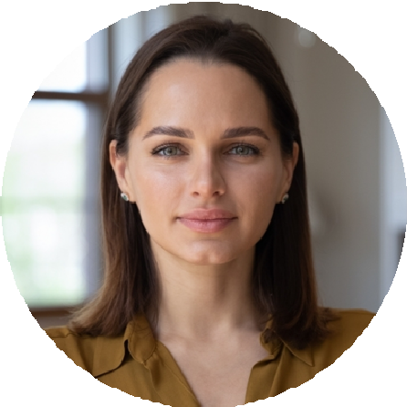

EDUCATION
Master of Science in Organizational Leadership
New York University, New York, NY | May 2015

