Sam Wright

Retail Personal Shopper

Customer-focused Personal Shopper with a flair for fashion and efficiency
Retail Personal Shopper with 4 years of experience curating outfits, managing client profiles, and delivering a concierge-level shopping experience. Known for translating style preferences into standout looks and increasing purchase volume.

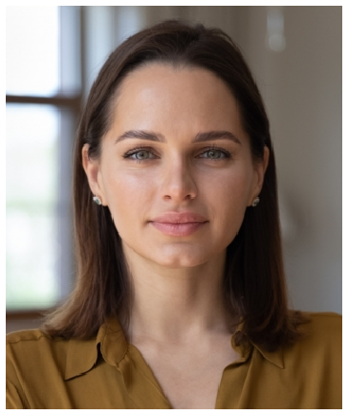




Personal information

(123) 456-7890

sam.wright@email.com City, ST 11238

Education
BACHELOR OF ARTS IN FASHION MARKETING | LIM COLLEGE | NEW YORK, NY | MAY 2019

Key skills
Client consultations Fashion styling
Gift recommendations
Order personalization Product matching Trend forecasting

Professional experience
PERSONAL SHOPPER | SHOPSMART LUXE, BROOKLYN, NY | APRIL 2021 - PRESENT

Manages client portfolios for over 40 regular customers
Increased average transaction value by 40% through outfit bundling strategies
Creates monthly style reports for returning clients

RETAIL SALES ASSOCIATE | STREETSTYLE COLLECTIVE, NEW YORK, NY | JUNE 2019 - MARCH 2021

Worked closely with the personal shopping team to identify VIP customers
Assisted with appointment scheduling and product prep Restyled window mannequins weekly to reflect trends

