Reese King
Social Media Copywriter

Social Media Copywriter with five years of experience crafting brand-aligned messaging for lifestyle, health, and retail brands. Skilled in writing captions, CTA testing, and platform-specific tone. Known for increasing click-through and engagement through clear, targeted messaging.

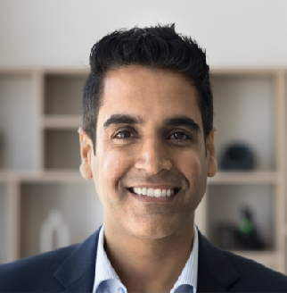
PERSONAL INFORMATION

 (000) 000-0000
 reese.king@email.com  LinkedIn | Portfolio  San Diego, CA 92101

EDUCATION

Bachelor of Arts (B.A.) in Creative Writing

San Diego State University, San Diego, CA | May 2018

KEY SKILLS

- Brand voice development
- Caption writing
- Cross-platform copy
- CTA testing
- Social headlines

PROFESSIONAL EXPERIENCE

SOCIAL MEDIA COPYWRITER | WELLTH CO., SAN DIEGO, CA FEBRUARY 2021 – PRESENT
Wrote daily Instagram and LinkedIn captions that improved overall engagement rate by 52% over one year
A/B tested CTA formats across platforms, resulting in a 19% boost in link clicks and landing page views
Collaborated with graphic designers to align messaging and visual elements for campaigns

CONTENT WRITER | NICHENEST MEDIA, SAN DIEGO, CA JUNE 2018 – JANUARY 2021
Produced weekly captions and headlines for email and social assets across five client accounts
Helped establish brand voice guidelines, improving content consistency and team efficiency
Tracked post performance weekly to refine messaging and adjust strategy

CERTIFICATIONS

HubSpot Content Marketing Certification | 2022 Meta Certified Creative Strategy Professional | 2021

