Aidan Black
Site Reliability Engineer (SRE)

Personal

INFORMATION

(555) 567-9876

aidan.b@email.com GitHub | Portfolio Dallas, TX

Site reliability engineer specializing in infrastructure automation
Experienced software engineer with seven years of reliability engineering, monitoring, and automation expertise.

Professional Experience
SITE RELIABILITY ENGINEER | CLOUD INFRASTRUCTURE SOLUTIONS | DALLAS, TX
JUNE 2018 - PRESENT

Automated incident response and monitoring, reducing downtime by 50% Improved system reliability, achieving 99.99% uptime
Developed scalable cloud solutions, reducing operational costs

Education

Key skills
Bachelor of Science in Computer Science Texas A&M University | May 2017

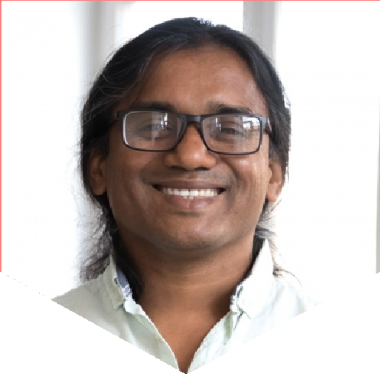

Kubernetes, Docker, Terraform
AWS, Google Cloud, Azure
CI/CD pipelines, monitoring (Prometheus, Grafana)
Load balancing, disaster recovery

